Slightly Above Average

Unnamed Game

Table of Contents

Overview 3

Theme/Setting/Genre 3

Core Gameplay/mechanics 3

Target Platforms 3

Budget 3

Time scale 3

Team 3

Licences/Hardware 3

Influences 3

Elevator Pitch 3

Project description – brief 3

Project description - detailed 3

What sets the game apart? 4

Core gameplay mechanics/what can the players do? 4

Story and gameplay 4

Story (brief) 4

Story (detailed) 4

Game play (brief) 4

Game play (detailed) 4

Assets needed 4

2D 4

3D 4

Characters 4

Environmental art (stuff in the room) 4

Sound 4

Inside/outside/player 4

Animation 5

Concept art 5

Stretch goals 5

Milestones 5

## Overview

### Theme/Setting/Genre

3D timed item collection game with 2D puzzles.

Occasional action scenes.

### Core Gameplay/mechanics

1. Timed (5 – 15 minute games)
2. Score system (1 egg = 1 point)
3. Combat System (variety of attacks)
4. Enemy AI
5. Procedurally Generated rooms (?)

### Target Platforms

1. Windows 10
2. Virtual Reality

### Budget

£0.

(Cost of crème eggs. (Can buy a box of 30-40 on amazon for near £20. Sort it out when closer to date.))

### Time scale

7 months.

Game to be shown week ending 20th April 2018.

### Team

1. Katherine Axten
2. Jamie Chadd
3. Joseph Davies
4. Simon Goodfellow
5. James Hopkins
6. Adam Marke

### Licences/Hardware

University unity licence.

### Influences

1. The Witness (Game)
   1. 3D environment with 2D puzzles that need to be completed in order to progress within the game.
2. Crystal Maze (TV Show)
   1. Different puzzles in different rooms. Timed events.

### Elevator Pitch

A 3D find and collect game with 2D puzzles and fighting elements.

### Project description – brief

Players take on the role of the Easter bunny who is on a mission to collect as many eggs as possible within a time limit. For every egg that is found, a puzzle must be completed for the egg to be kept and the next room to spawn. Occasionally there will be evil bunnies out to steal your eggs whom you must defeat.

Rabbit ears grab joysticks. And the camera turns to the 2D puzzle monitor. (Rabbit is being sucked into the video game for certain puzzles.)

Optional Changes:

* Extra eggs in each room that are hidden.

### Project description - detailed

### What sets the game apart?

* Puzzle element adds extra features to the game as opposed to continuation after finding the object.

### Core gameplay mechanics/what can the players do?

## Story and gameplay

### Story (brief)

Possible ideas;

* The Easter bunny has not long been in the role and their first task is to collect all the poisoned eggs that previous bunnies have left in people’s homes. Occasionally the player will have to defeat an ex Easter bunny to complete his mission.

### Story (detailed)

### Game play (brief)

### Game play (detailed)

## Assets needed

### 2D

* Puzzles

### 3D

* Rooms
* Ears

### Characters

### Environmental art (stuff in the room)

* Chocolate eggs
* Doilies?
* Interactable objects.

### Sound

### Inside/outside/player

### Animation

### Concept art

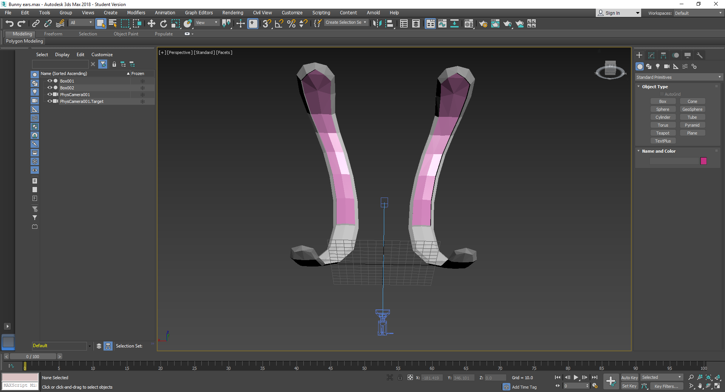

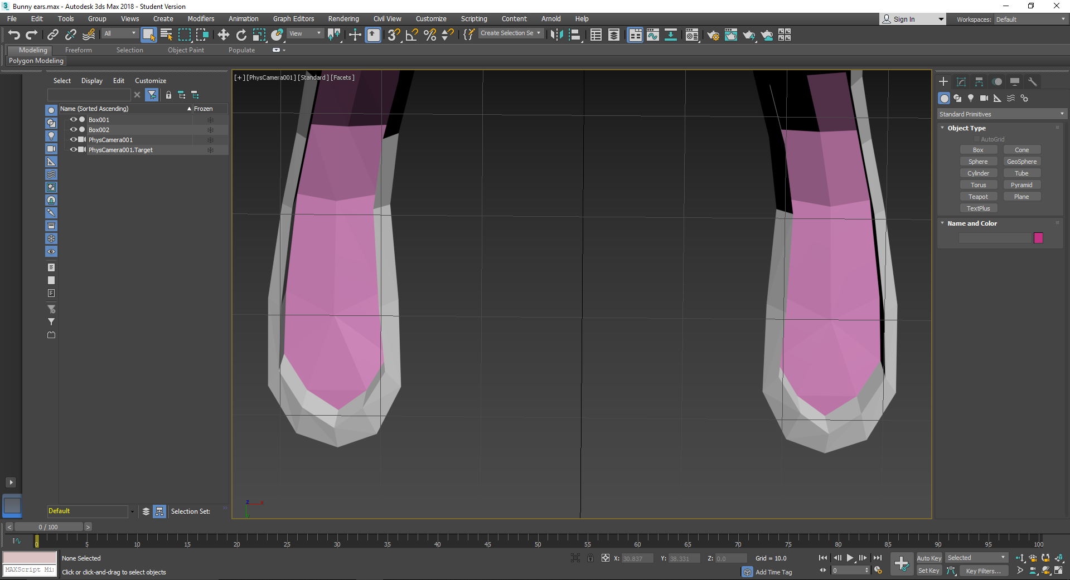

### Stretch goals

* Achievement system

## Milestones

### Puzzle Ideas:

* Slide puzzle (hit piece with ears to move) 2D/3D

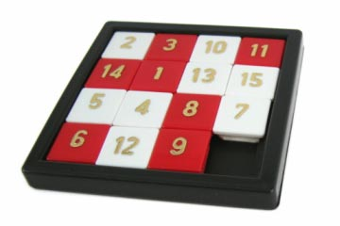

* Sudoku 2D/3D (Ear slap the empty tiles to fill with number (e.g. Slap tile 5 times, number is 5)

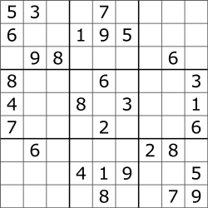

* Connect the dots 2D/3D (Hold starter tile to connect the dots.)

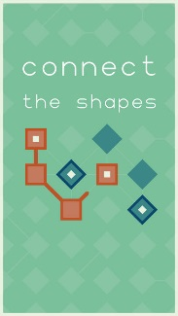

* 2D platformer. The bunny turns into a 2D platformer character.
  + Harder Levels: enemies, slippery floor.